**PROMETHEUS (CM)**

1. **What is Prometheus?**
2. Prometheus is an open-source monitoring and alerting toolkit originally developed by SoundCloud in 2012 and later donated to the Cloud Native Computing Foundation (CNCF) in 2016. It is widely used in the field of cloud-native and containerized environments for monitoring and managing the health and performance of various systems and applications.

**Key features of Prometheus include:**

**Time Series Database**: Prometheus stores all the collected monitoring data as time-series, allowing it to track and analyse metrics over time.

**Metrics Collection**: Prometheus pulls metrics data from various sources, such as applications, services, and system components, through an HTTP-based pull model. These sources need to expose their metrics in a specific format called the Prometheus exposition format.

**Query Language**: Prometheus provides a powerful query language called PromQL (Prometheus Query Language) that allows users to perform complex queries and aggregations on the collected metrics.

**Alerting**: Prometheus has a built-in alerting mechanism that allows users to define alerting rules based on specific conditions and thresholds. When a rule is triggered, it can send alerts to various channels like email, Slack, or other alerting systems.

**Service Discovery:** Prometheus supports service discovery, making it easier to monitor dynamic systems like container orchestration platforms (e.g., Kubernetes) where instances of applications and services can change rapidly.

**Grafana Integration**: Prometheus is often used in combination with Grafana, a popular open-source visualization tool. Grafana can connect to Prometheus and create interactive, visually appealing dashboards to display monitoring data.

Prometheus has become an essential part of many cloud-native deployments due to its flexibility, scalability, and ability to handle high-dimensional data. It plays a crucial role in helping developers and operators gain insights into the performance and health of their systems, troubleshoot issues, and ensure reliability in modern, distributed infrastructure environments.

1. **What is prometheus exporter?**
2. A Prometheus Exporter is a part of software that allows it to fetch statistics from another, non-prometheus system. It converts those statistics into prometheus metrics, using a client library. You can start a web server which exposes a /metrics URL, and can see that URL display the system metrics.
3. **How To Install & configure prometheus, node_exporter and grafana on Ubuntu 20.04/22.04?**
4. **For standalone installation of prometheus, node_exporter and grafana on UBUNTU 20.04/22.04 follow the following steps**

**To properly configure Prometheus, you must follow the below mentioned steps.**

**STEP-1: UPDATE SYSTEM PACKAGES**

**sudo apt update && sudo apt upgrade**

**STEP-2: CREATE PROMETHEUS USER AND GROUP**

**First, create the “prometheus” system group using the following command**

**sudo groupadd --system prometheus**

**Next, create the “prometheus” system user using the following command**

**sudo useradd -s /sbin/nologin --system -g prometheus Prometheus**

**STEP 3: CREATE DIRECTORIES FOR PROMETHEUS**

**sudo mkdir /var/lib/Prometheus**

**Next, create the primary configuration files directory for Prometheus using the following command. All Prometheus related data will be stored in this folder.**

**for i in rules rules.d files_sd; do sudo mkdir -p /etc/prometheus/${i}; done**

**STEP 4: DOWNLOAD PROMETHEUS**

**First check whether curl is available or not in UBUNTU, as follows**

**curl –version**

**If curl is available, the following message shown in screenshot will appear.**

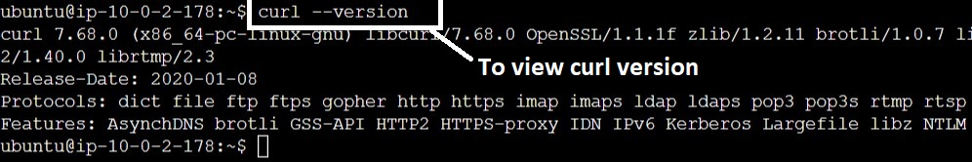

**After that, run the following commands for downloading the Prometheus.**

**mkdir -p /tmp/prometheus**

**cd /tmp/prometheus**

**curl -s https://api.github.com/repos/prometheus/prometheus/releases/latest | grep browser_download_url | grep linux-amd64 | cut -d '"' -f 4 | wget -qi -**

**After executing the above commands, Prometheus will gets downloaded in that folder.**

**STEP 5: EXTRACT PROMETHEUS**

**Once you have downloaded the latest version of Prometheus for your Ubuntu system, you can extract the software using the following command.**

**tar xvfz prometheus-*.*.*.linux-amd64.tar.gz**

**After executing the above command, the following messages shown in screen will appear.**

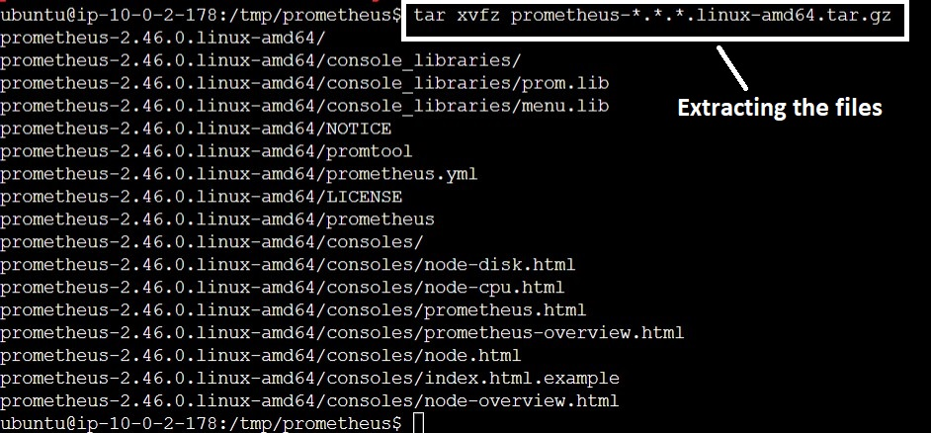

**Then, enter into the extracted folder by using the following command**

**cd prometheus*/**

**After entering into that folder, run the following commands for configuring the Prometheus.**

**Next, move the binary files to the /usr/local/bin/ directory using the following command.**

**sudo mv prometheus promtool /usr/local/bin/**

**To verify the installation of Prometheus, you can use the following commands.**

**prometheus --version**

**promtool --version**

**After executing the above commands, the following message will get displayed.**

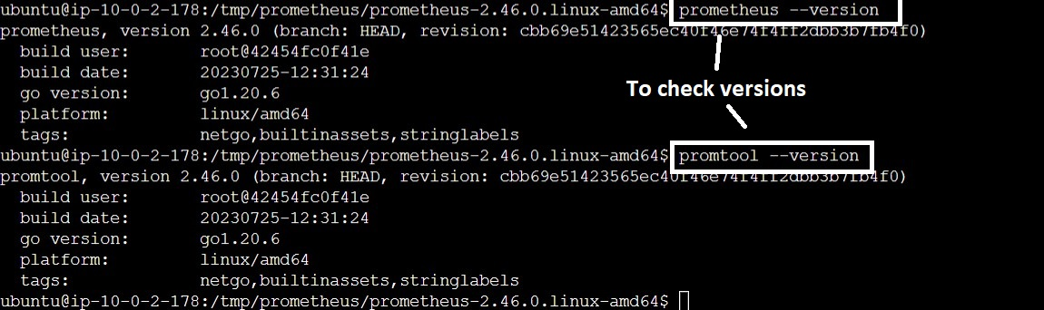

**Then, move the Prometheus configuration template to the /etc/prometheus/ directory using the following command**

**sudo mv prometheus.yml /etc/prometheus/prometheus.yml**

**Finally, move the consoles and console_libraries directories to the /etc/prometheus/ directory using the following command.**

**sudo mv consoles/ console_libraries/ /etc/prometheus/**

**cd $HOME**

**STEP 6: CREATE SYSTEMD SERVICE**

**By default, Prometheus does not come with a systemd service, which makes it difficult to manage and control the software.**

**To, create the systemd service file using the following command.**

**sudo vi /etc/systemd/system/prometheus.service**

**After creating prometheus.service file, you have to paste the following content in it and save it.**

**[Unit]**

**Description=Prometheus**

**Documentation=https://prometheus.io/docs/introduction/overview/**

**Wants=network-online.target**

**After=network-online.target**

**[Service]**

**Type=simple**

**User=prometheus**

**Group=prometheus**

**ExecReload=/bin/kill -HUP \$MAINPID**

**ExecStart=/usr/local/bin/prometheus \**

**--config.file=/etc/prometheus/prometheus.yml \**

**--storage.tsdb.path=/var/lib/prometheus \**

**--web.console.templates=/etc/prometheus/consoles \**

**--web.console.libraries=/etc/prometheus/console_libraries \**

**--web.listen-address=0.0.0.0:9090 \**

**--web.external-url=**

**SyslogIdentifier=prometheus**

**Restart=always**

**[Install]**

**WantedBy=multi-user.target**

**Next, change the directory permissions for the Prometheus user and group using the following commands, one by one.**

**for i in rules rules.d files_sd; do sudo chown -R prometheus:prometheus /etc/prometheus/${i}; done**

**for i in rules rules.d files_sd; do sudo chmod -R 775 /etc/prometheus/${i}; done**

**sudo chown -R prometheus:prometheus /var/lib/prometheus/**

**After changing the directory permissions, reload the systemd daemon using the following command.**

**sudo systemctl daemon-reload**

Finally, to start the Prometheus systemd service use the following command.

**sudo systemctl start prometheus**

**After starting the prometheus service, use the following command to view the status.**

**sudo systemctl status prometheus**

**After executing the above command, the following screen will appear.**

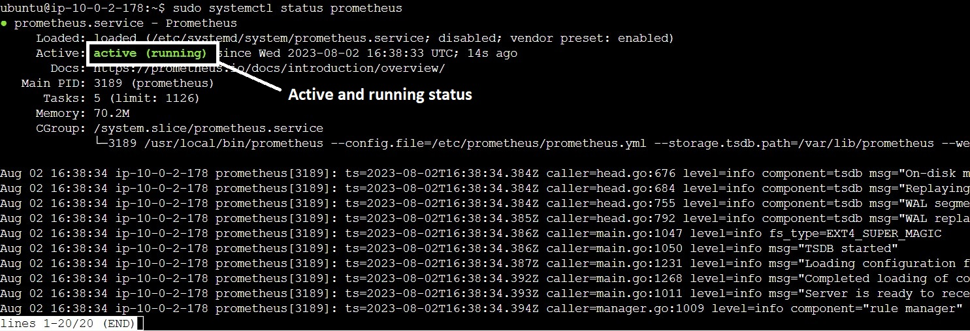

**To start the Prometheus service automatically, when system startup, use the following command.**

**sudo systemctl enable prometheus**

**The following message will appear.**



**STEP 7: CONFIGURE SECURITY GROUPS/ UFW FIREWALL**

**Option-1: If you are using UBUNTU in local machine, you have to allow the ports and enable the UFW status. By using the following commands.**

**sudo ufw status (It displays the UFW status)**

**sudo ufw allow 9090/tcp**

**sudo ufw allow 9093/tcp**

**After executing the above commands, you have to enable the UFW by using the following commands.**

**sudo ufw enable**

**Option-2: If you are using UBUNTU in AWS cloud, you have to edit inbound rules for the ports 9090 and 9093 in the security groups.**

**STEP 8: ACCESS PROMETHEUS WEB UI**

**After completion of above steps, to view prometheus web page use the following URL in browser.**

**http://YOUR_IP:9090/**

**The following page will appear.**

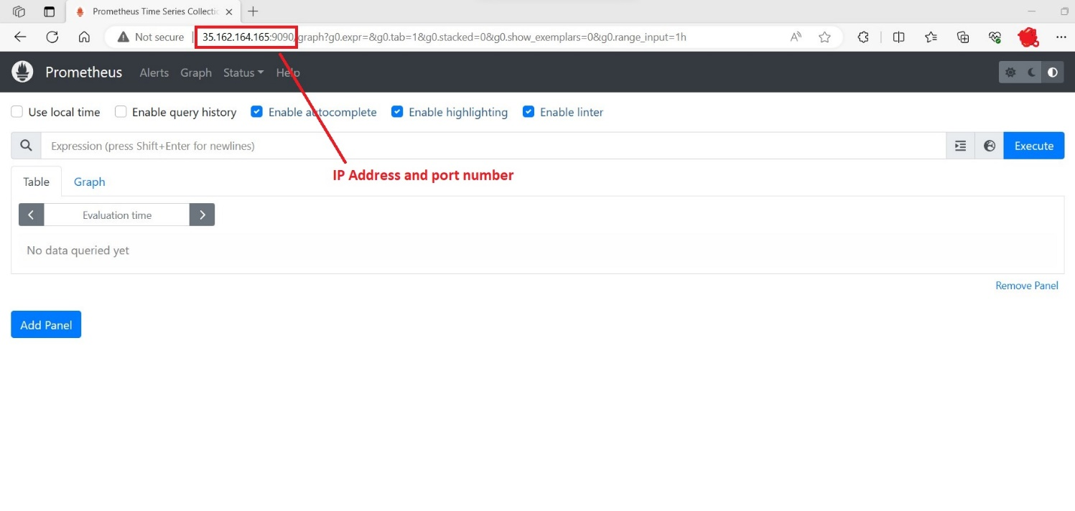

**If you are seeing this page, prometheus setup was completed successfully.**

**Node_Exporter Installation**

**Now we have to install node_exporter for monitoring linux system and visualize the data, Grafana need to be installed and integrated with node_exporter as follows.**

**To download node_exporter, first enter into /opt directory. As follows**

**cd /opt**

**Then, we have to execute the following commands for downloading the node_exporter.**

**sudo wget https://github.com/prometheus/node_exporter/releases/download/v1.6.1/node_exporter-1.6.1.linux-amd64.tar.gz**

**After completion of downloading the file, extract that folder by using the following commands.**

**sudo tar -xvzf node_exporter-1.6.1.linux-amd64.tar.gz**

**After extracting the file, rename the folder by using the following commands**

**sudo mv node_exporter-1.6.1.linux-amd64 node_exporter**

**By, default node_exporter was not starting automatically. So, to set it we have to create a systemd service file, by using the following commands.**

**sudo vi /etc/systemd/system/node_exporter.service**

**paste the following content in that service file**

**[Unit]**

**Description=Prometheus Node Exporter**

**Documentation=https://github.com/prometheus/node_exporter**

**After=network-online.target**

**[Service]**

**User=root**

**EnvironmentFile=/etc/default/node_exporter**

**ExecStart=/opt/node_exporter/node_exporter $OPTIONS**

**Restart=on-failure**

**RestartSec=5**

**[Install]**

**WantedBy=multi-user.target**

**After saving the file, you have to run the following command.**

**sudo systemctl daemon-reload**

**After that, create the options file by using the following commands**

**sudo vi /etc/default/node_exporter**

**We have to paste the following content into that file.**

**OPTIONS=''**

**To start the service at system startup. We have to execute the following commands.**

**systemctl enable node_exporter**

**After executing the above command, the following message will appear.**



**To start the node_exporter service, execute the following commands.**

**systemctl start node_exporter**

**To view the status, execute the following command.**

**systemctl status node_exporter**

**After executing the above command, the following message will appear.**

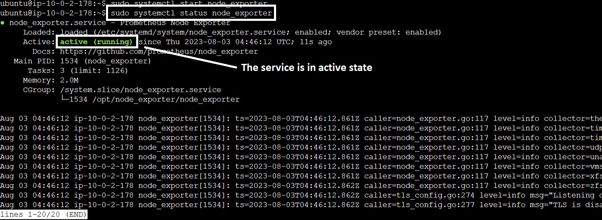

**To check the node_exporter web UI, execute the following URL in your browser, node_exporter port number is 9100.**

**http://Your_IP:9100/**

**After entering that URL in browser, the following page will appear.**

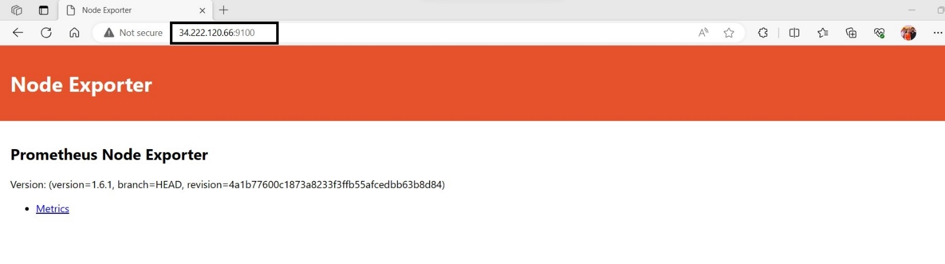

**As this page appears, you have successfully installed node_exporter.**

**Integration of prometheus and node_exporter**

**For collecting linux system metrics, we need node_exporter and it have to be integrated with prometheus server. For collecting metrics.**

**Follow the below steps, for integrating both**

**vi /etc/prometheus/prometheus.yml**

**After opening that file, you will see the following screen.**

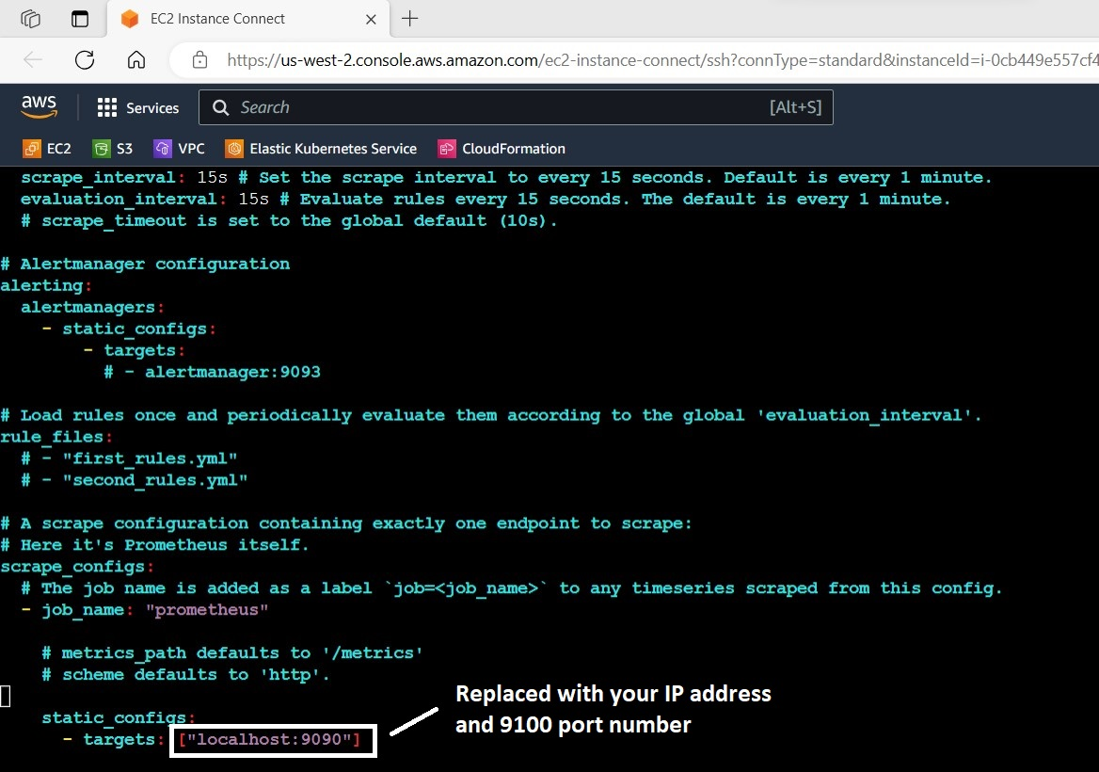

**At the bottom, you will find the following lines, there you have to edit those. In place of localhost IP address shall be given and in place of 9090 port, you have to give 9100**

**static_configs:**

**- targets: ["localhost:9090"]**

**After replacing the IP and port number, save the file and restart the prometheus.service by using the following commands.**

**- targets: ["34.222.120.66:9100"]**

**sudo systemctl restart prometheus.service**

**Now, prometheus and node_exporter had integrated. We can view that in web UI, as shown below.**

**http://Your_IP:9090**

**The following page will appear**

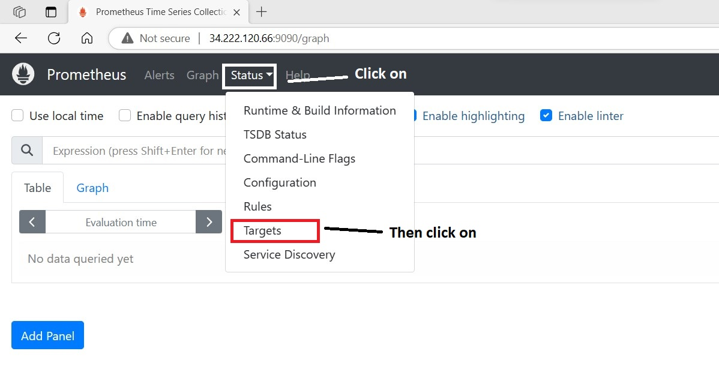

**After clicking on targets option, the following page will appear.**

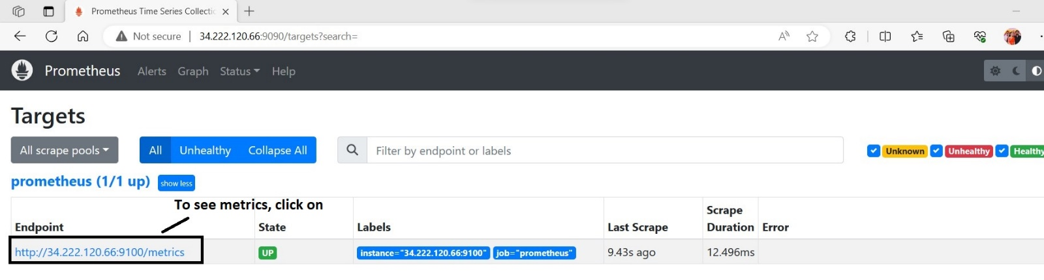

**After clicking on that link, to see metrics the following page will appear.**

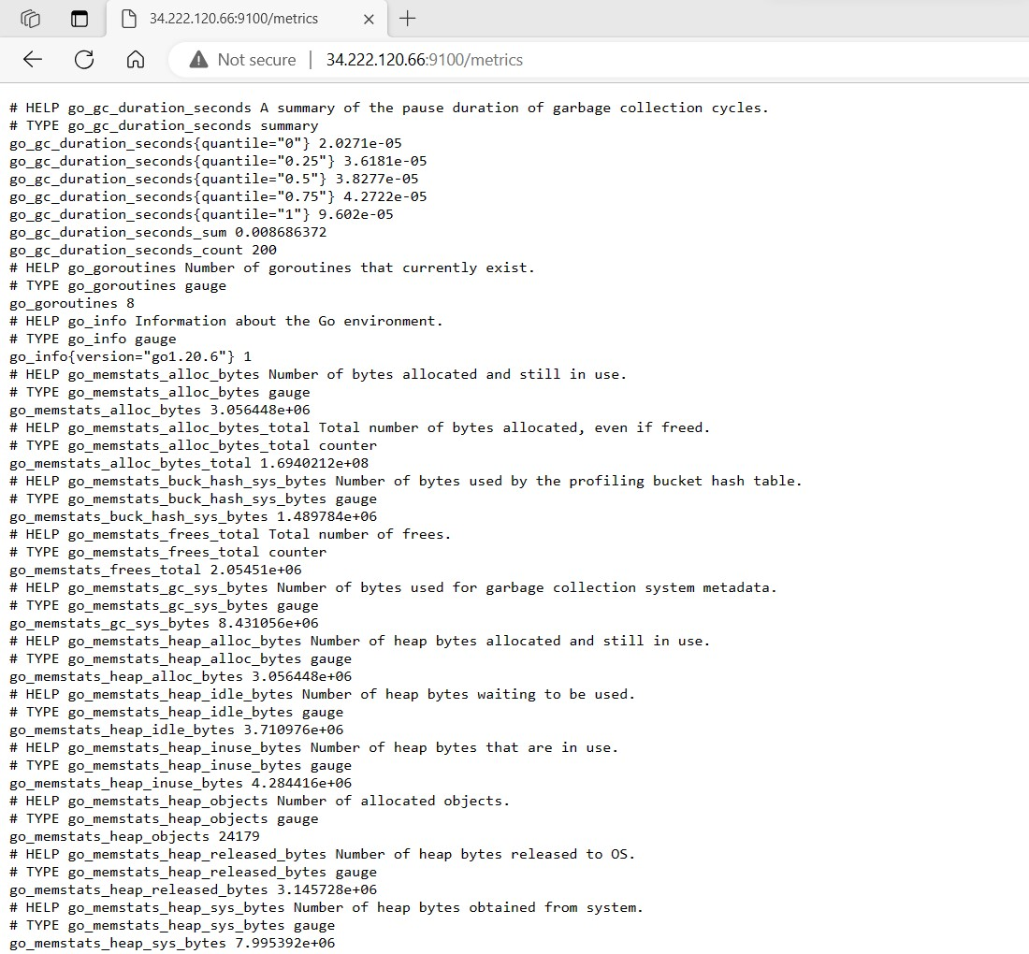

**You can see the logs and metrics, but we cannot understand those metrics. To visualize the data received from node_exporter. We have to install Grafana and it shall be integrated.**

**Grafana Installation**

**To install the grafana, you have to execute the following commands in UBUNTU.**

**sudo apt-get install -y adduser libfontconfig1**

**wget https://dl.grafana.com/enterprise/release/grafana-enterprise_10.0.3_amd64.deb**

**sudo dpkg -i grafana-enterprise_10.0.3_amd64.deb**

**After executing the above commands, the following message screen will appear.**

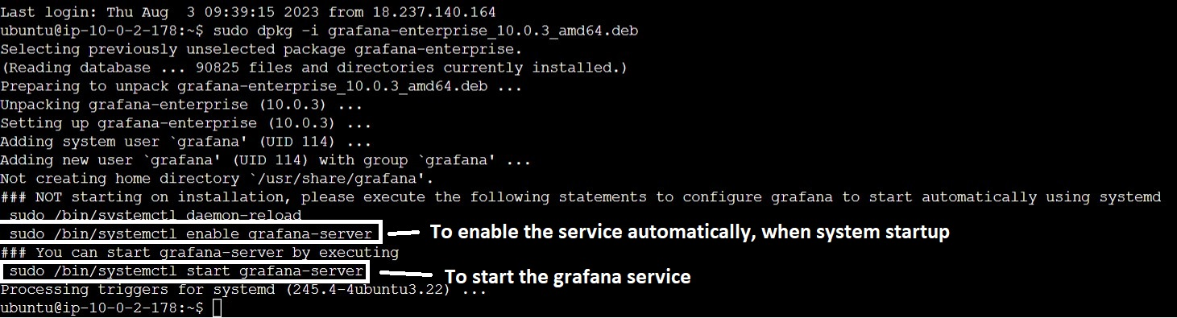

**To enable the grafana server start automatically, when system start-up, we have to execute the following commands.**

**sudo systemctl enable grafana-server**

**To start the grafana server, execute the following command.**

**sudo systemctl start grafana-server**

**To check the grafana server status, execute the following command.**

**sudo systemctl status grafana-server**

**After executing the above command, the following message will appear.**

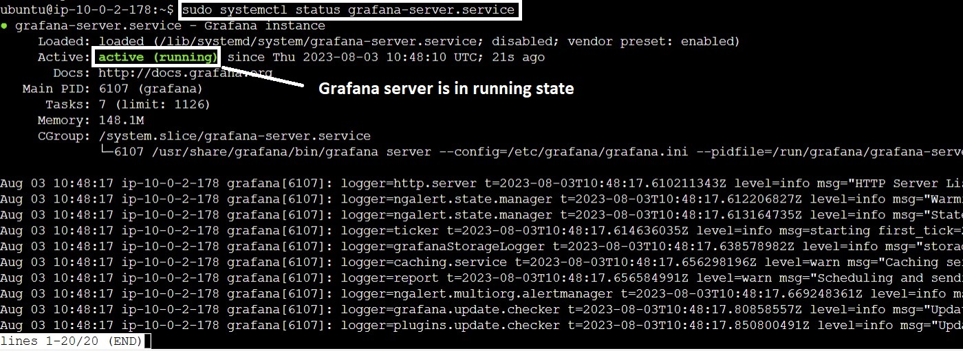

**As, it shows the server in active state. We have to open the following URL in browser, to view web UI. Grafana server port number is 3000.**

**http://your_ip:3000/**

**The following page will display.**

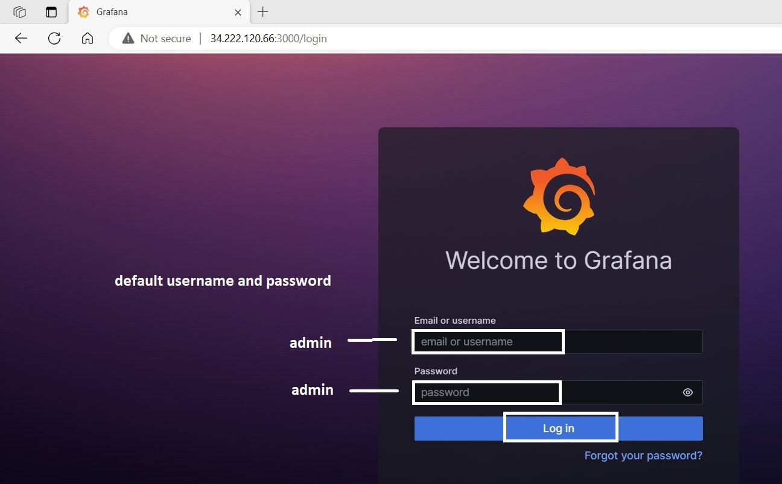

**You have to enter username- admin and password- admin, after entering those click on ‘log in’ button.**

**After clicking on that log in button. The following page will appear.**

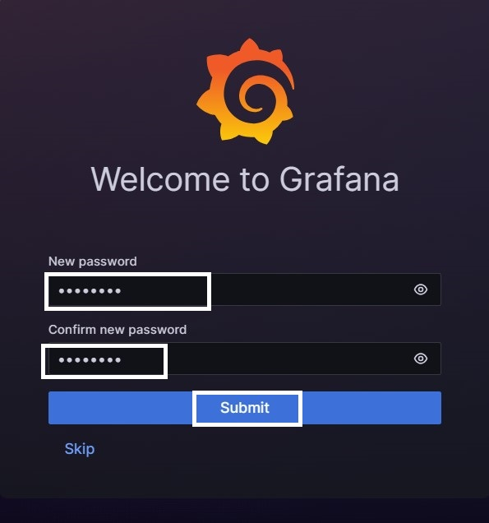

**We have to set new password for grafana server and click on submit button.**

**After clicking on submit button, the following page will appear.**

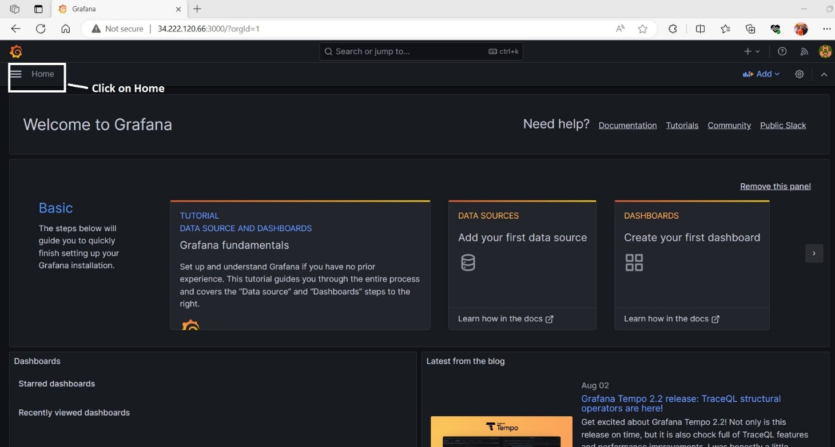

**After clicking on home button, the following options screen will display.**

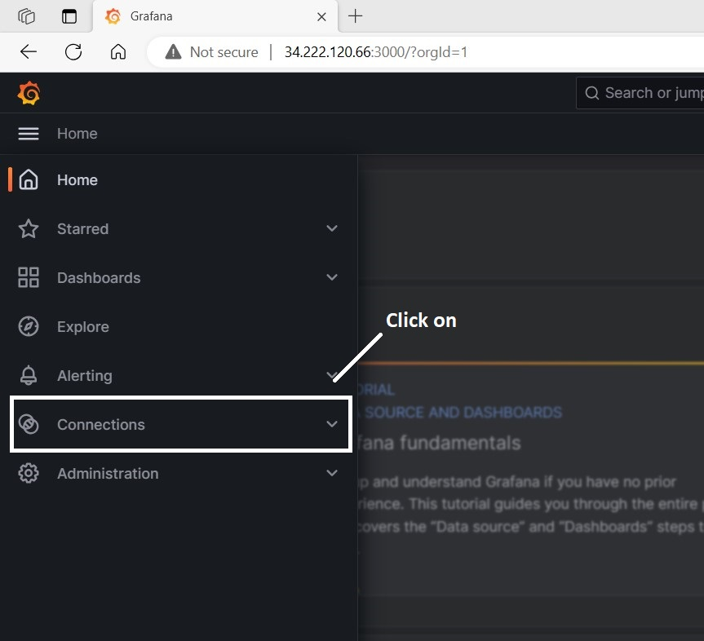

**After clicking on connections button, the following page will display.**

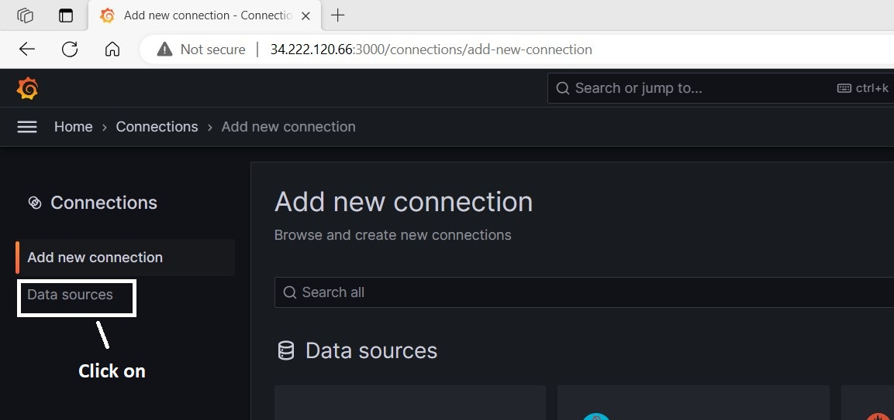

**After clicking on ‘data sources’ button, the following page will be appeared.**

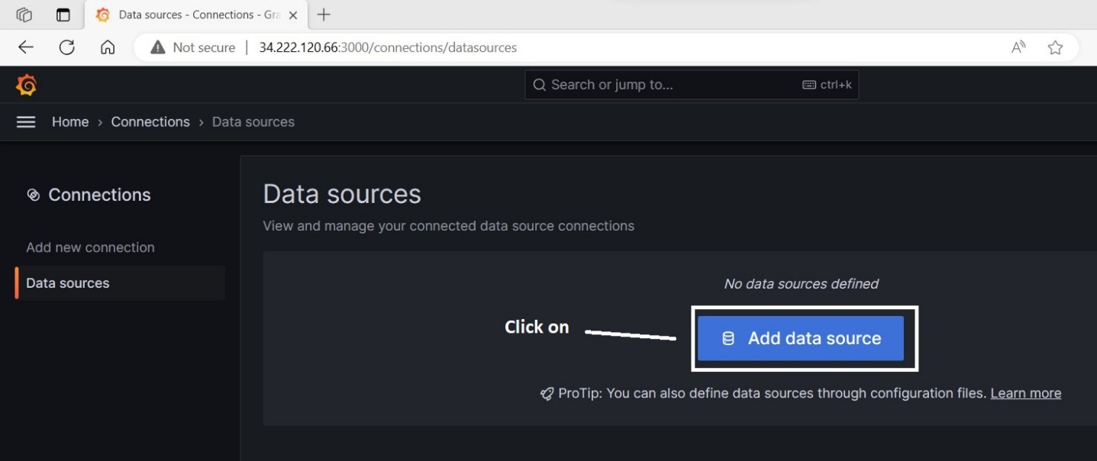

**After clicking on ‘Add data source’ button, the following page will be appeared.**

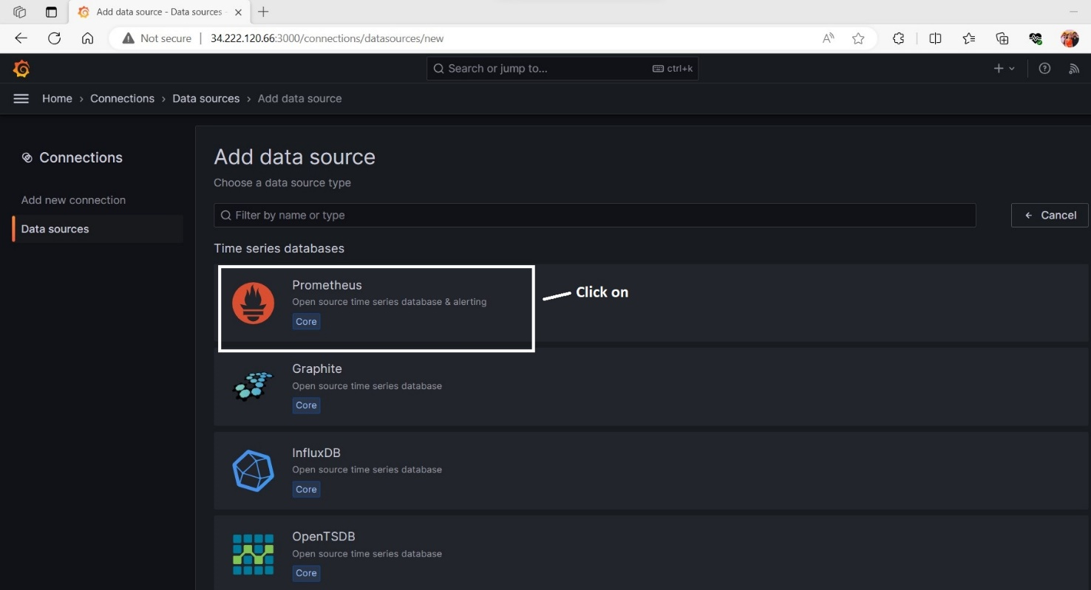

**After clicking on ‘prometheus’ button, the following page will display.**

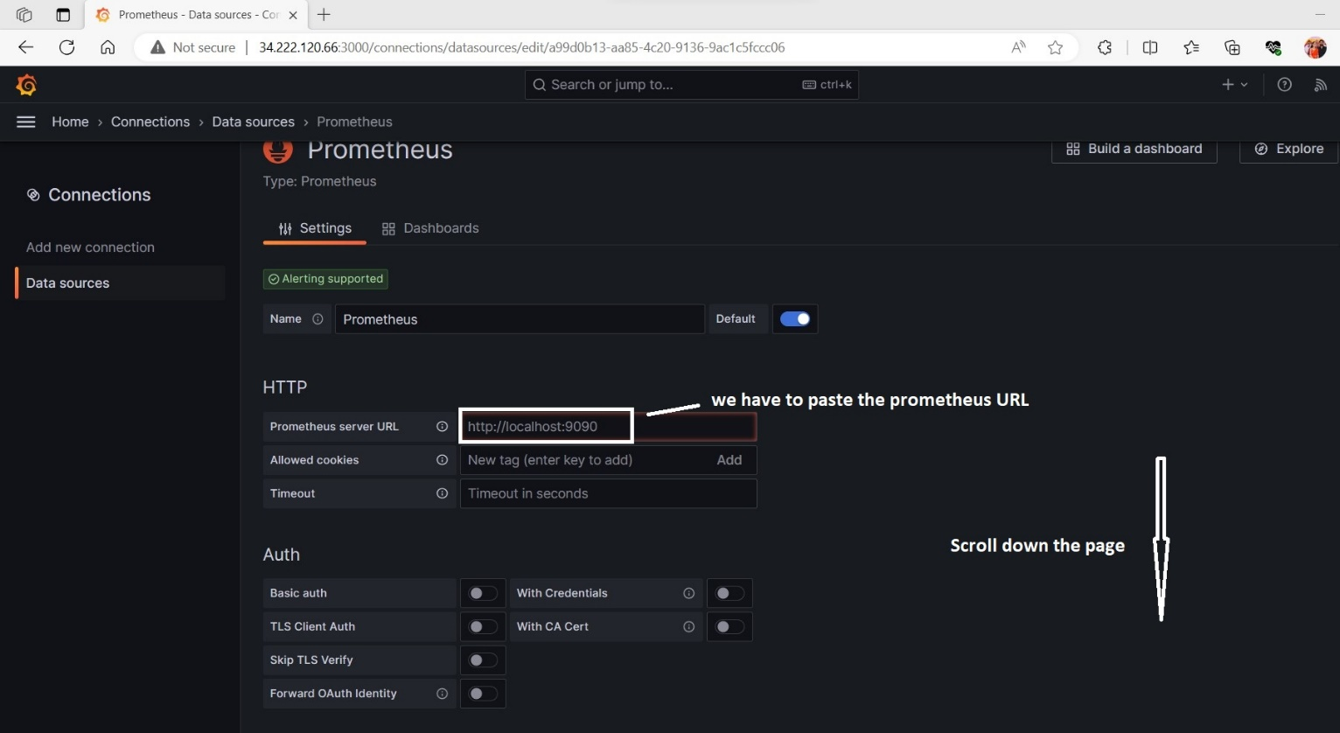

**After scrolling down the above page, the following page will appear.**

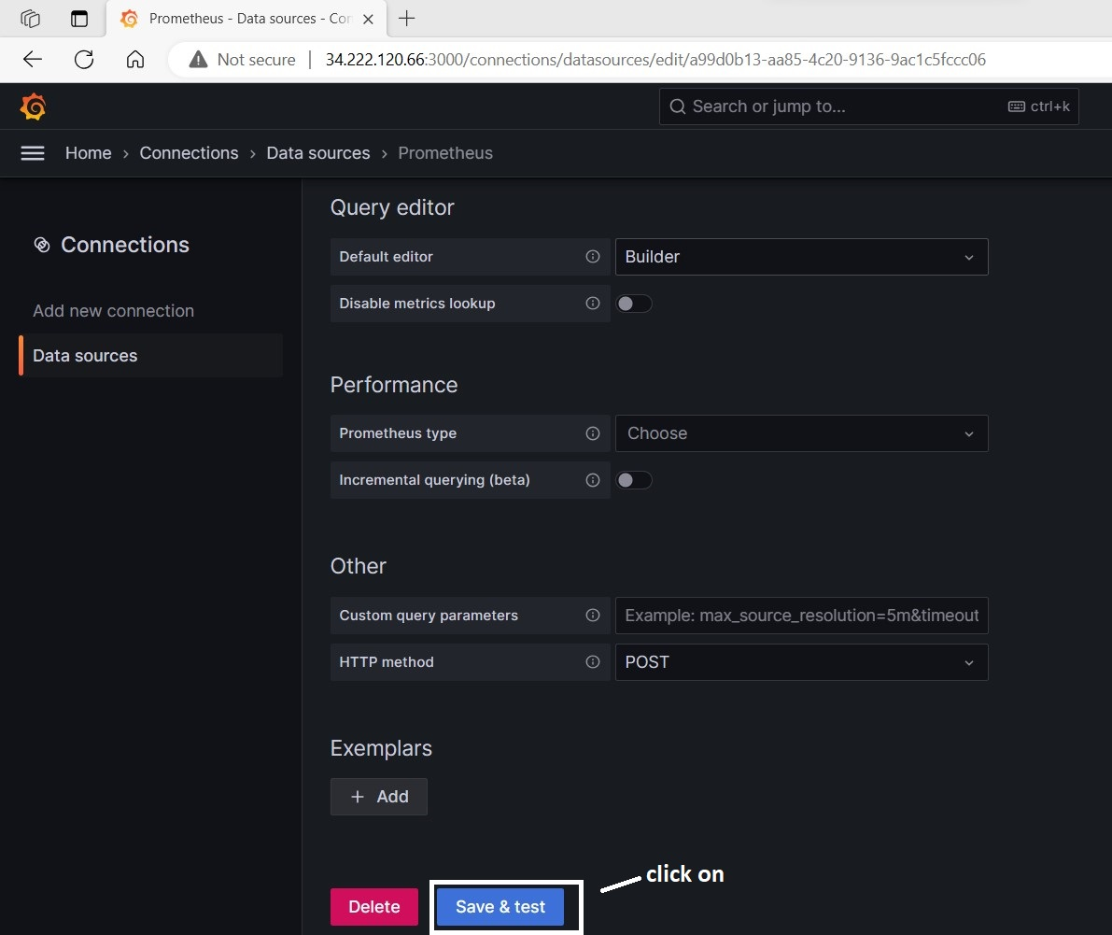

**After clicking on ‘save&test’ button the following message will appear.**

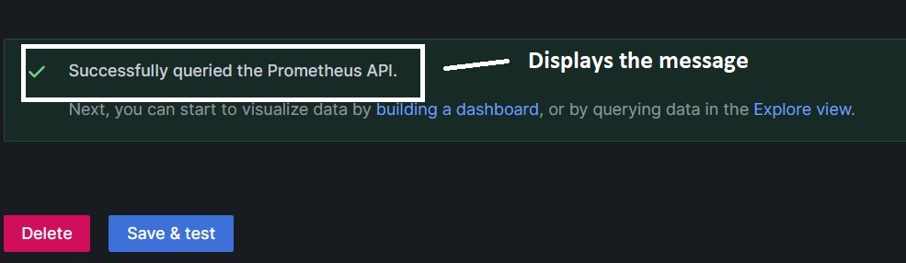

**After that again click on home button, the following page will appear.**



**After that, clicking on home button. The following page will display.**

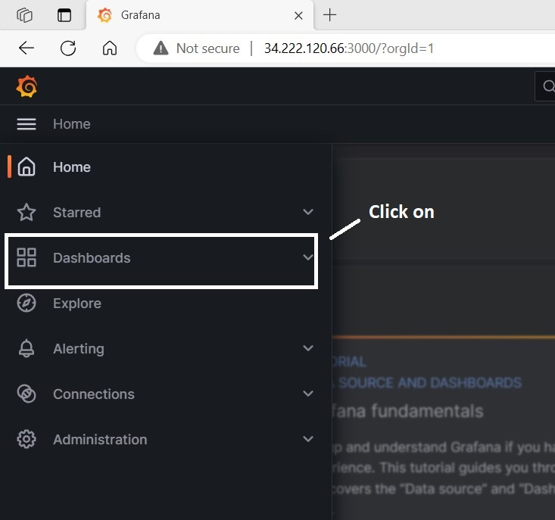

**After clicking on ‘dashboards’ button, the following page will appear.**

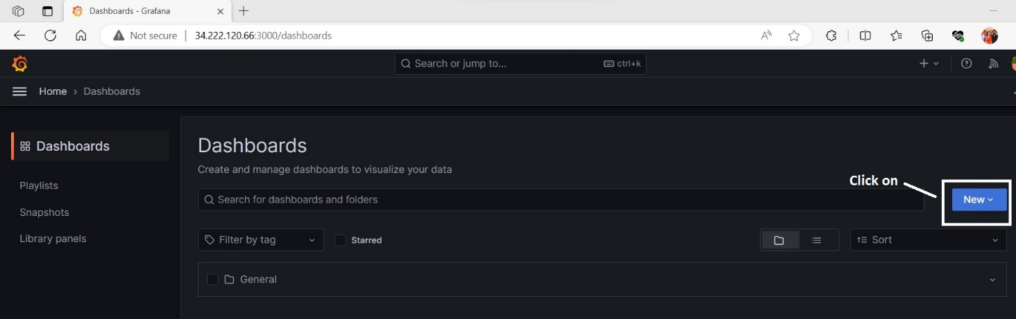

**After clicking on, new dropdown menu. The following page will display.**

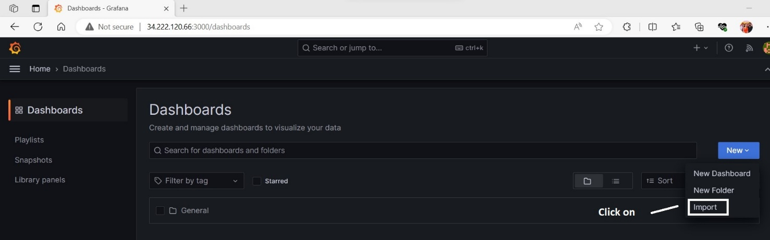

**After clicking on ‘import’ button, the following page will appear. (Dashboard id-10180)**

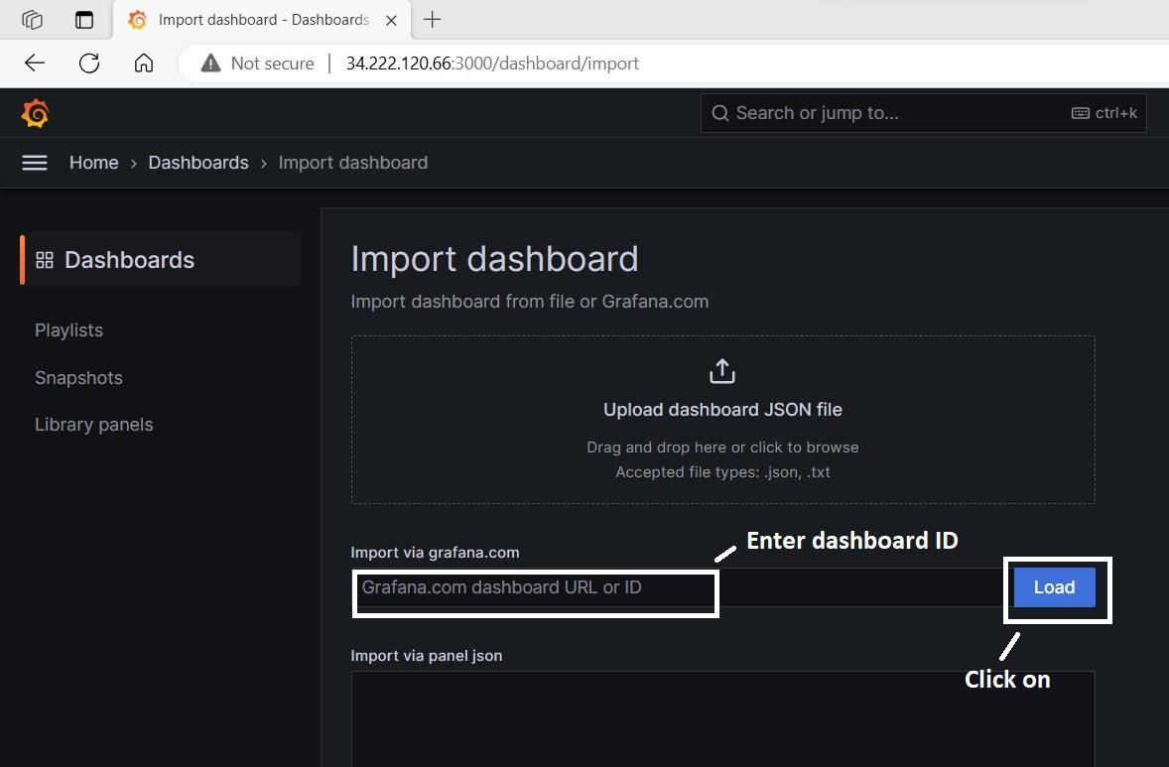

**After clicking on ‘Load’ button, the following page will get display.**

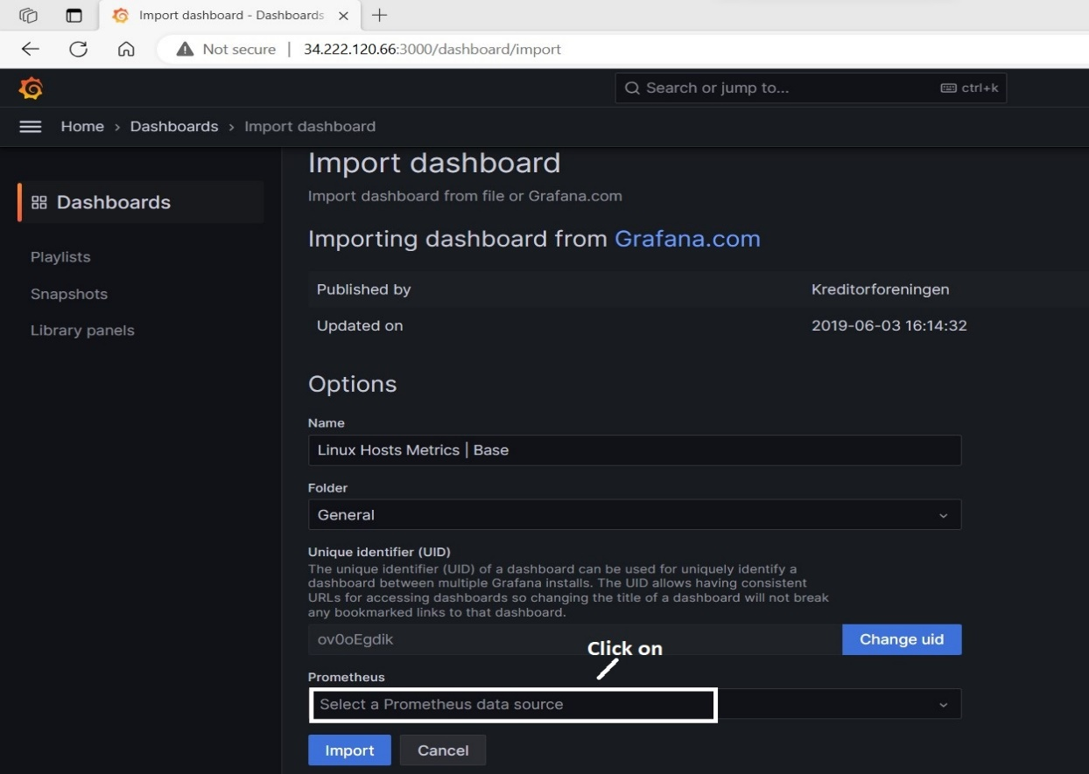

**After clicking on that, the following options will get display.**

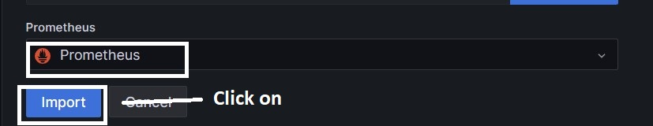

**After clicking on ‘import’ button, the following dashboard page will display.**

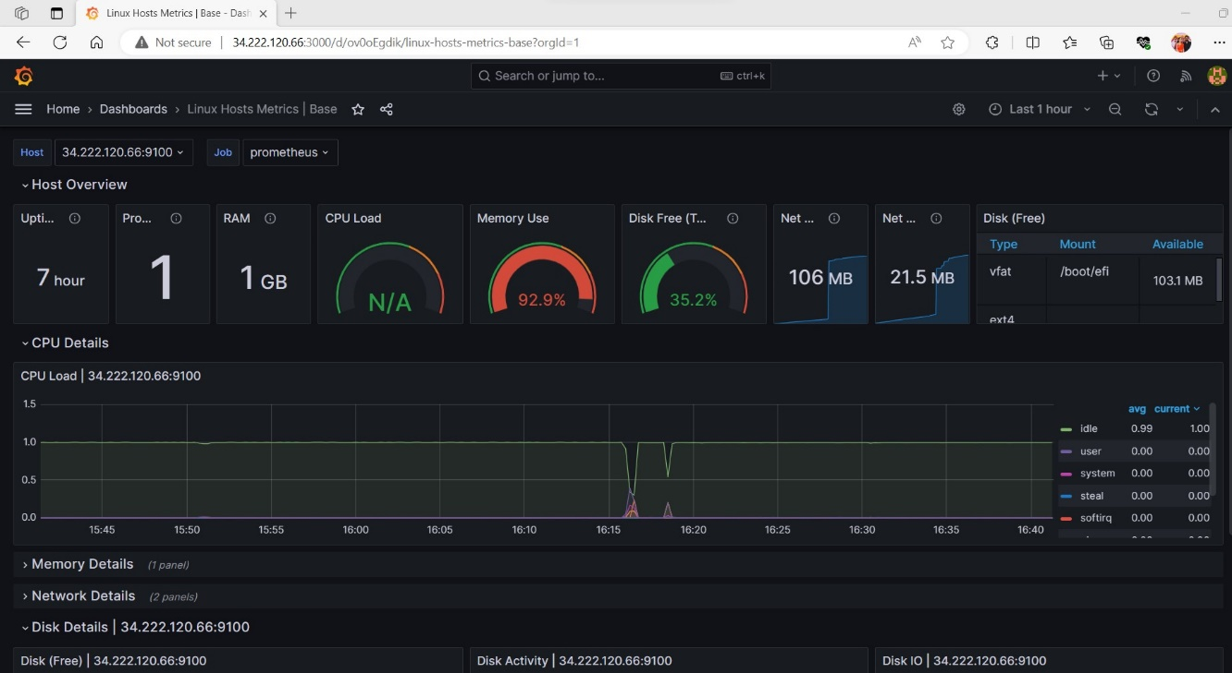

**Finally, standalone installation and configuration of prometheus, node_exporter and grafana was successfully completed.**